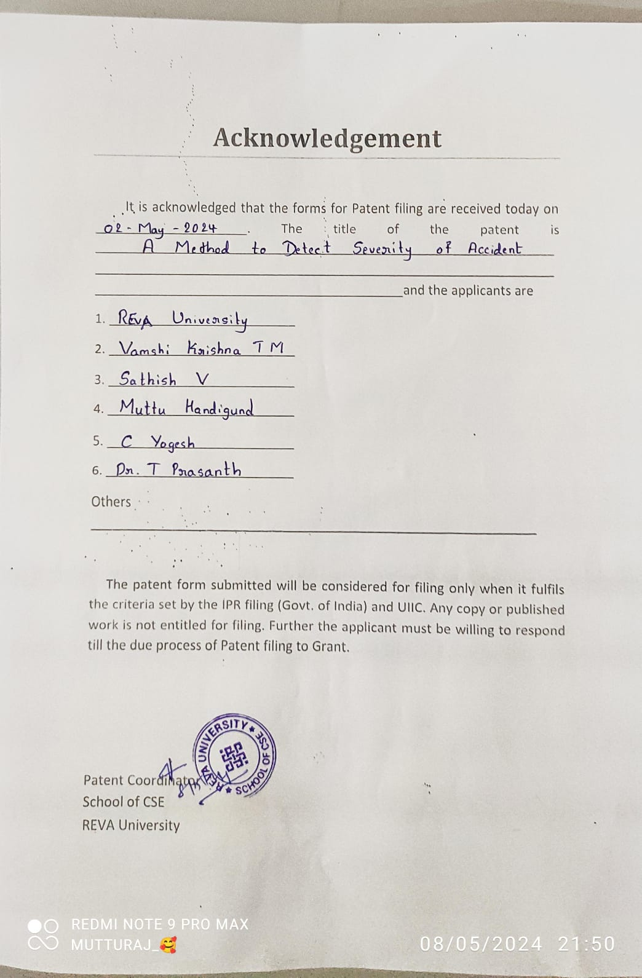Title: Accident Data Analysis

Group: D2